PRODUCT DETAILS

**DATE JUST 41**

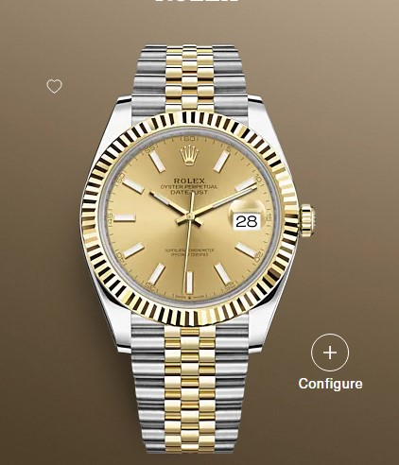

**$2199.99**

**Specifications**

**MODEL CASE**: Oyster, 41 mm, Oystersteel and yellow gold

**OYSTER ARCHITECTURE**: Monobloc middle case, screw-down case back and winding crown

**DIAMETER**: 41 mm

**MATERIAL**: Yellow Rolesor - combination of Oystersteel and 18 ct yellow gold

**BEZEL**: Fluted

**WINDING CROWN**: Screw-down, Twinlock double waterproofness system

**CRYSTAL**: Scratch-resistant sapphire, Cyclops lens over the date

**WATER RESISTANCE**: Waterproof to 100 metres / 330 feet

**MOVEMENT**: Perpetual, mechanical, self-winding

**CALIBRE**: 3235, Manufacture Rolex

**PRECISION**: -2/+2 sec/day, after casing

**FUNCTIONS**: Centre hour, minute and seconds hands. Instantaneous date with rapid setting. Stop-seconds for precise time setting

**OSCILLATOR**: Paramagnetic blue Parachrom hairspring. High-performance Paraflex shock absorbers

**WINDING**: Bidirectional self-winding via Perpetual rotor

**POWER RESERVE**: Approximately 70 hours

**BRACELET**: Jubilee, five-piece links

**BRACELET MATERIAL**: Yellow Rolesor - combination of Oystersteel and 18 ct yellow gold

**CLASP**: Folding Oysterclasp with Easylink 5 mm comfort extension link